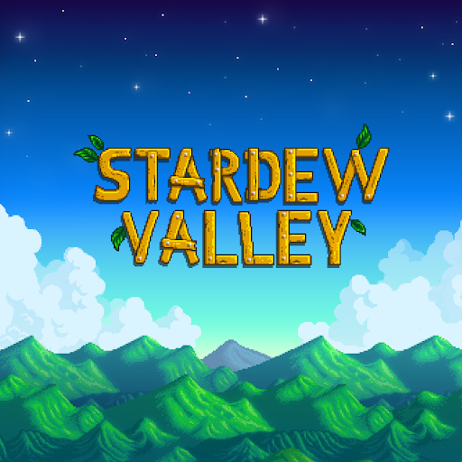

## **The Sims™ 4 :**

## **STARDEW VALLEY.**

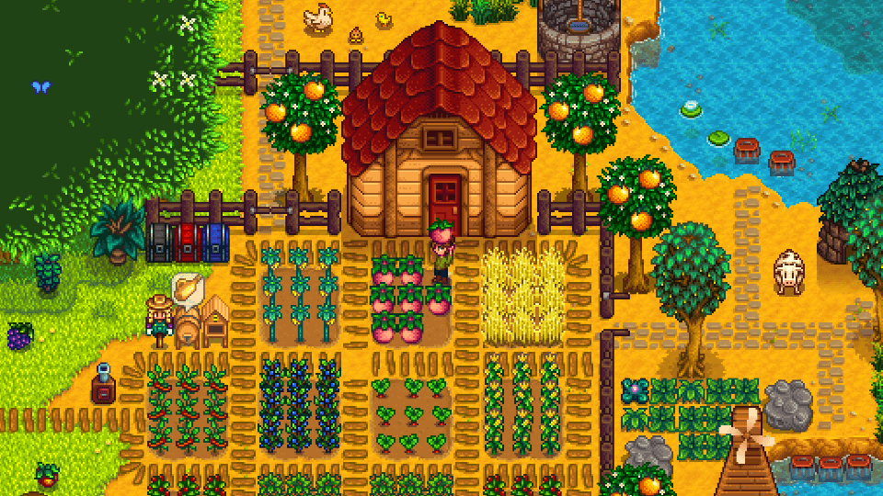

You’ve inherited your grandfather’s old farm plot in Star dew Valley. Armed with hand-me-down tools and a few coins, you set out to begin your new life. Can you learn to live off the land and turn these overgrown fields into thriving homes? It won’t be easy. Ever since Joja Corporation came to town, the old ways of life have all but disappeared. The community center, once the town’s most vibrant hub of activity, now lies in shambles. But the valley seems full of opportunity. With a little dedication, you might just be the one to restore Stardew Valley to greatness! Purchasing this content entitles you to both the PS4™ system and “PS Vita” system versions!